**CHAPTER III**

**METHODOLOGY**

This research study utilized the Developmental Research methodology. It is the systematic study of designing, developing, and evaluating instructional programs, processes, and products that must meet criteria of internal consistency and effectiveness. In addition, this study uses the descriptive type of analysis in presenting the data through the dashboard of the system.

**Software Life Cycle Model**

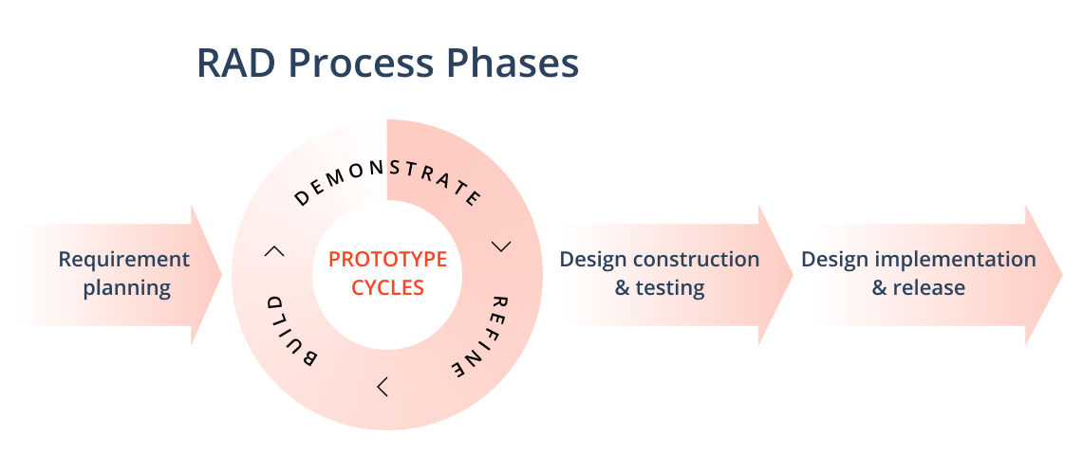In this study, the researcher used the Rapid Application Development (RAD) model in developing the software.

**Figure 2. Rapid Application Development Model**

This study uses the Rapid Application Development approach to construct its system because it is a common project management strategy for software development. The key advantage of the RAD technique is the speed with which the project may be completed, making it an appealing option for engineers working in fast-paced contexts like software development. The focus of RAD on minimizing the planning stage and maximizing prototype development allows for this quick step. RAD helps programmers to precisely assess progress and communicate in real-time about problems or changes that are occurring by reducing planning time and prioritizing prototype iteration. As a result, there is more efficiency, faster development, and better communication **(Hamzah, et.al., 2019)**.

**RAD Software Phases**

Here are the following phases involved in developing a system using Rapid Application Development:

**Stage 1. Requirement Planning**

Existing challenges in the enrollment process components of the institution that require automation of records and data processing were properly discussed with the administrators at this stage. The response to the current and foreseeable challenges of the manual enrollment process was decided by setting goals and expectations. Planning for the construction of the system was thoroughly completed in collaboration with enrollment employees, office administrators, and the researcher, and needed needs were carefully reviewed and study objectives were explicitly specified for targets.

**Step 2. Prototype Cycles (Demonstration, Refine, Build)**

The system is scoped out through feedbacks after extensive planning with the administrators, and the creation of the system architecture begins in this step.

The researcher will construct a model of the system (prototyping) in this step, and then offer the developed module to the client for testing. All identified faults and defects in the module will be forwarded to the developer for correction. During this phase, the client and the developer collaborate closely and communicate frequently. This sort of procedure iterates until all of the system's scopes are met and the design's expectations are met.

**Step 3. Design Construction and Testing**

This phase of the Madridejos Community College Enrollment System is designed to test the system's functionality while verifying that the vast majority of the expected functionalities are operational. Changes, upgrades, and/or extra features and/or modules may be added to the system during this phase in response to client requests and demands. Client feedback allows the system's code to be modified and retested at this phase.

**Software testing** is the process of comparing a system's requirements to the real requirements to find any flaws, gaps, or missing requirements. There are two forms of software testing: functional testing and non-functional testing (**Bennett, 2021)**.

The researcher permitted the MCC Enrollment Staff to utilize the system and explore its functions and modules to test the System. An evaluation form has been issued to collect input on the system's functionality to make and/or apply any necessary improvements.

The USE Questionnaire: Usefulness, Satisfaction, and Ease of Use questions, as well as the ISO/IEC 25010 software characteristics questionnaires, were employed. The ISO/IEC 25010 Software Quality Model questionnaires were utilized by the IT expert group.

The Madridejos Community College Enrollment System was put to the test by users and specialists. The system's overall output is 100 percent operational and error-free, based on the system's requirements. The outcome demonstrates that the developer complies with the user's expectations and standards.

**Step 4. Design Implementation and Release**

This is the final step before the finalized work is released to the public. It entails data conversion and user training on how to utilize the system. The system is now executing its function, but it must still be continuously monitored and maintained in this phase.

#### **Schedule Feasibility**

**Gantt Chart**

Figure 3 shows the timetable of the project – from scratch up until it is being fully developed into a useful system. It also displays the length of time a certain task needs for a deliverable to be finished.

**Figure 3. Gantt Chart**

In project management, a Gantt chart is a popular tool. It essentially drills down activities that must be completed within a certain time frame. It's frequently used to keep track of project timelines. The vertical axis on the chart shows the various tasks to be completed, while the horizontal axis reflects the time allotted.

**Requirements Modeling**

**Context Flow Diagram**

Context Flow Diagram is the highest form of a Data Flow Diagram (DFD) and is also known as Level 0 DFD. It draws attention to the flow of data between the system and external components **(Edrawsoft, 2021)**.

All external elements that may interact with a system are represented in a system context diagram. The entire software system is represented as a single process. The system is depicted at the middle of the diagram, with no specifics of its internal structure, and is surrounded by all of its external entities, interacting systems, and environments **(Visual Paradigm, 2021)**.

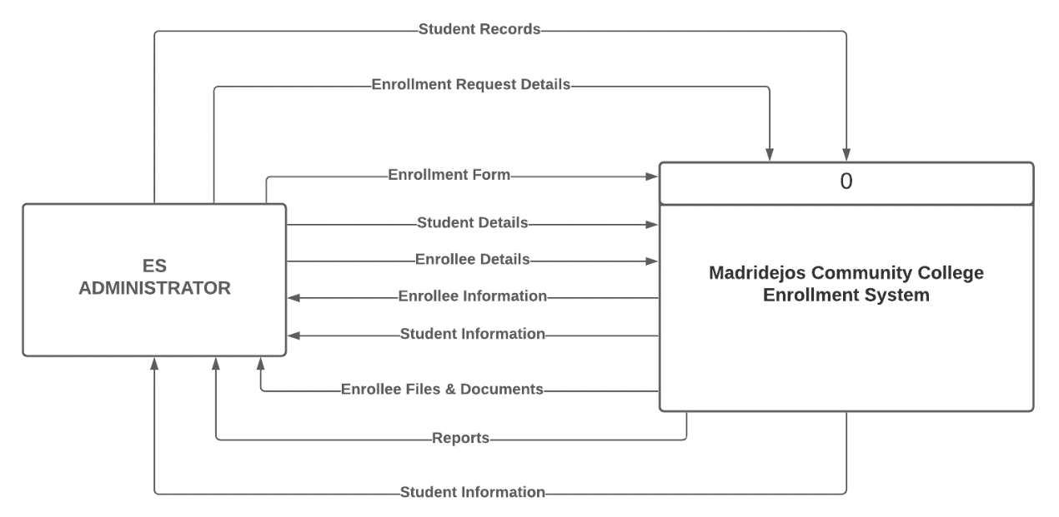

**Figure 4. Context Flow Diagram**

**Data Flow Diagram­­­­­­­­­­­­­­­­­**

The Data Flow Diagram (DFD) is a graphic representation of data flow that is commonly used in business information systems. It also outlines the processes involved in transporting data from the input phases to the storage phase and the development of reports in a system.

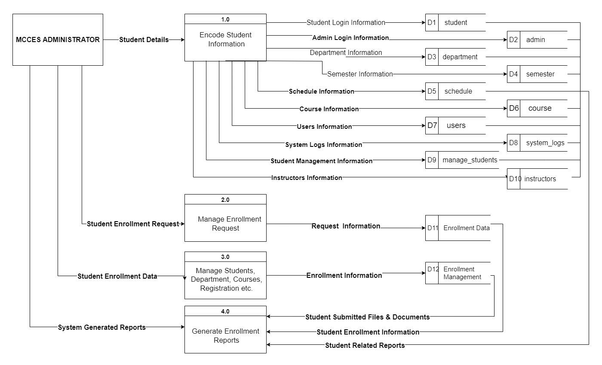 The procedure of the MCC Enrollment System is depicted in the diagram below. Users will get knowledge of the system's features, sequences, and procedures as a result of this illustration.

**Figure 5. Data Flow Diagram**

There are two types of data flow diagrams: logical and physical. The logical data flow diagram depicts the movement of data through a system to fulfill specific business functions. The physical data flow graphic depicts how the logical data flow is implemented.

**Entity – Relationship Diagram**

When entities, their related properties, and relationships between them are observed and specified, an entity-relationship diagram (ERD) depicts the logical structure of databases. An entity is a data component that refers to an object. A group of almost identical entities with characteristics that describe comparable properties is referred to as an entity set **(Smartdraw, 2021)**.

The entity-relationship diagram (ERD) is one of the most common diagrammatic representations of a conceptual data model in a database system that represents users' data requirements. In today's corporate climate, the business model is always changing, resulting in highly dynamic data requirements that necessitate additional processes such as ERD updates **(Nergiz, 2013)**.

The Entity-Relationship Diagram of the MCC Enrollment System is shown in Figure 6. It will provide you with snapshots of how the entities in one system are related to one another.

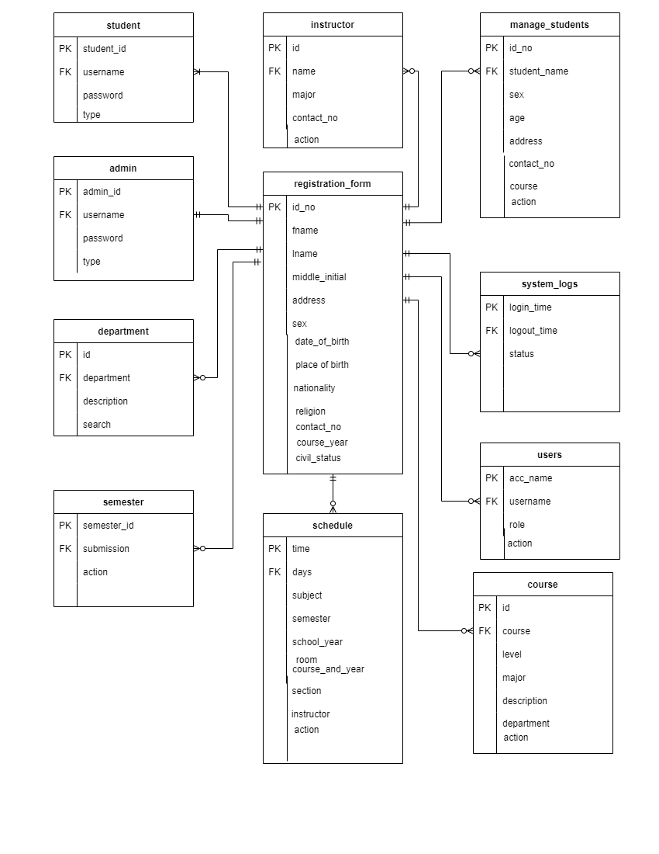

**Figure 6. Entity-Relationship Diagram**

**Application Architecture**

The Application Design for the MCC Enrollment System depicts the system's general architecture, including which devices and technologies are employed in its execution.

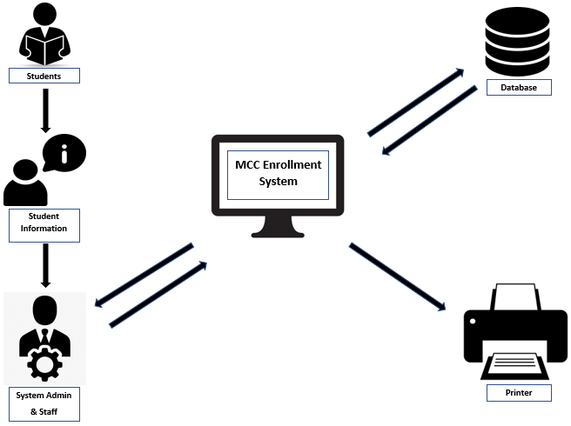

**Figure 7. Application Architecture**

Application architecture depicts the hardware and software components that make up an actual system's backbone. It also specifies how applications communicate with middleware, databases, and other programs. Application architectures normally correspond to widely known software design principles, but they may lack explicit industry standards **(Ferguson, 2019)**.

It may also include the system's conceptual model, which specifies the system's structure and behavior. The technical foundation, end-user requirements and a list of system components are all examples of system architecture **(Whitsett, 2018).**

**Use-Case Diagram**

Use case diagrams are commonly used to collect system requirements that contain both external and internal impacts. Actors are employed to represent the system's users to study the system's features **(Waykar, 2015)**.

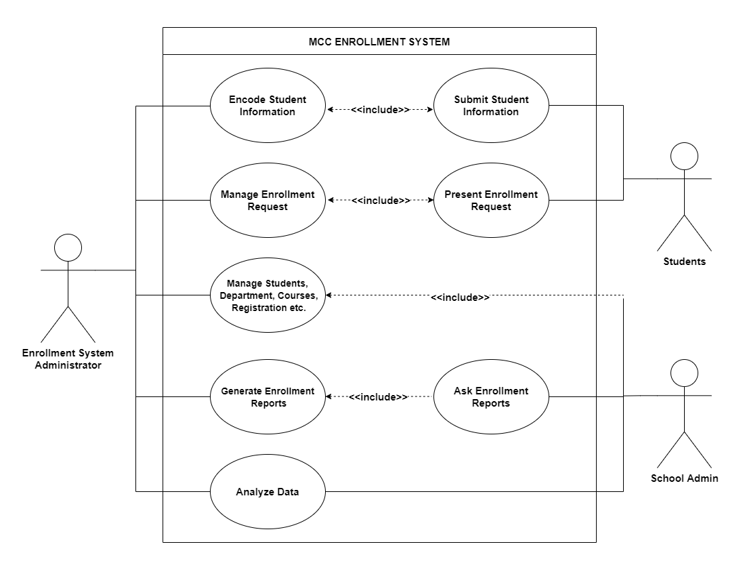 Use Case Diagrams are useful for collecting and displaying a dynamic view of a system's functionality during high-level requirement analysis. Internal and external entities that will interact with or use the system are being recognized as actors, also known as agents **(Dascalescu, 2018).**

**Figure 8. Use-Case Diagram**

Figure 8 illustrates the Use Case Diagram of the MCC Enrollment System which identifies four (3) actors: Enrollment System Administrator, Students, and the School Admin. These agents are considered an essential part of the system hence they are thought to be either direct or indirect users of the system.

**Software Requirements**

The following are the software requirements for the development and implementation of MCC Enrollment System:

* Windows 7 Operating System & Above
* System type: 32-bit
* XAMPP
* Google Chrome as a browser for better compatibility
* Bootstrap
* JQuery

**Hardware and Other Required Devices**

The following are the minimum hardware requirements of the system for it to be functional:

* **Processor:** Intel ® Core ™ i3-4030U CPU @ 1.9GHz
* **RAM:** 1.00 GB
* **Graphics:** Intel ® HD Graphics Control Panel
* **Peripheral:** Mouse, Keyboard/ Touchpad, and Printer

# **Programming Environment**

The interface of the system which is visible to the user is being developed using scripting languages such as HTML, CSS, Javascript, Bootstrap Framework, and JQuery. While for back-end, the programming language that was used is the PHP: Hypertext Pre-processor (PHP) which is much known for its lightweight capability and as an open-source scripting language. Most developers prefer using this scripting language to develop dynamic web pages which are usually being accompanied by Open-Source flexible database management software – MySQL.

**Test Plan**

To test the system, the researcher asked three IT Experts to validate the functionality of the system and to ensure that the system met its objectives and specifications by evaluating the following: the program design for its objectivity, validity, effectiveness, and completeness of system. The measuring tool used in Expert Testing is the ISO/IEC 25010 Software Quality Model.

**CHAPTER IV**

**PRESENTATION, ANALYSIS, AND INTERPRETATION OF RESULTS**

After the thorough evaluation of experts and respondents, the following are generated:

|  |  |  |
| --- | --- | --- |
|  | **Mean** | **Verbal Interpretation** |
| It can manage, display, and update student records. | **4** | Very Satisfactory |
| It can add subjects by  course & year. | **4** | Very Satisfactory |
| It can add courses by year. | **4.33** | Very Satisfactory |
| It can add class schedules. | **4.33** | Very Satisfactory |
| **Total** | **4.17** | **Very Satisfactory** |

**Table 1. In terms of managing, displaying, updating records, adding of subjects, courses, & class schedules**

Table 4 shows the result of the user’s feedback in using the Madridejos Community College system in terms of managing, displaying, updating records of students or enrollees, adding subjects by course & year, and in terms of adding courses. The table above shows a mean value of **4.17** which is interpreted as Very Satisfactory.

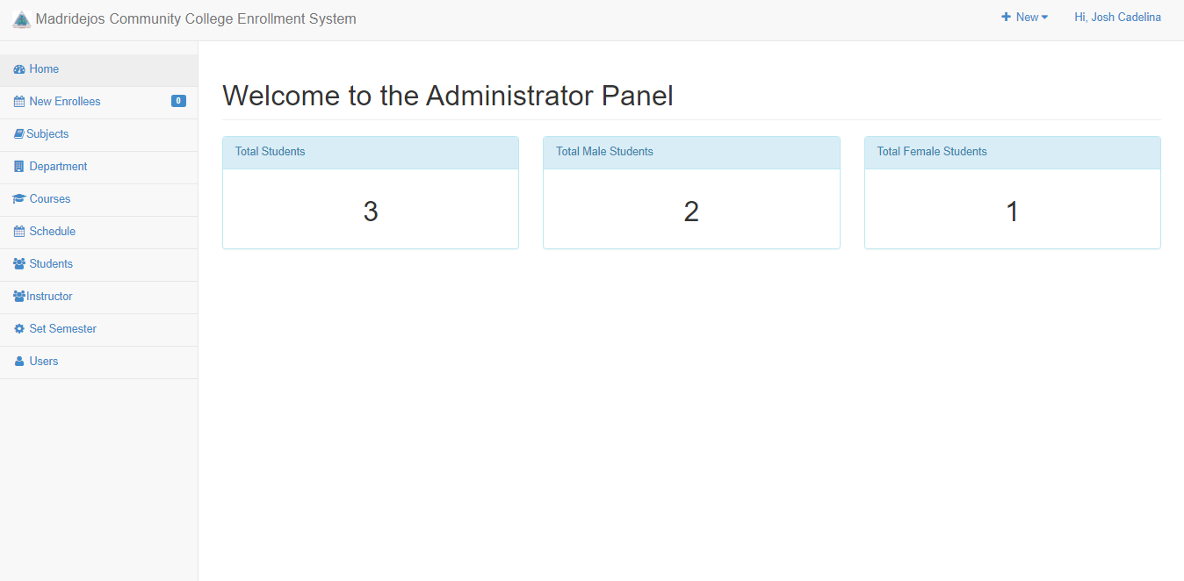

**Figure 9. MCC Enrollment System Main Page**

Figure 9 shows the main page of the Madridejos Community College Enrollment System which allows the admin to navigate through various navigations menus like New Enrollees, Subjects, Department, Courses, Schedule, Students, Instructors, Set Semester, and Users.

The main page also displays the diagrams to show the total number of enrolled students, and the number of male & female students. In terms of Functional Usability, the system is very versatile primary because it runs on a web browser and very easy also to navigate through the use of the mouse.

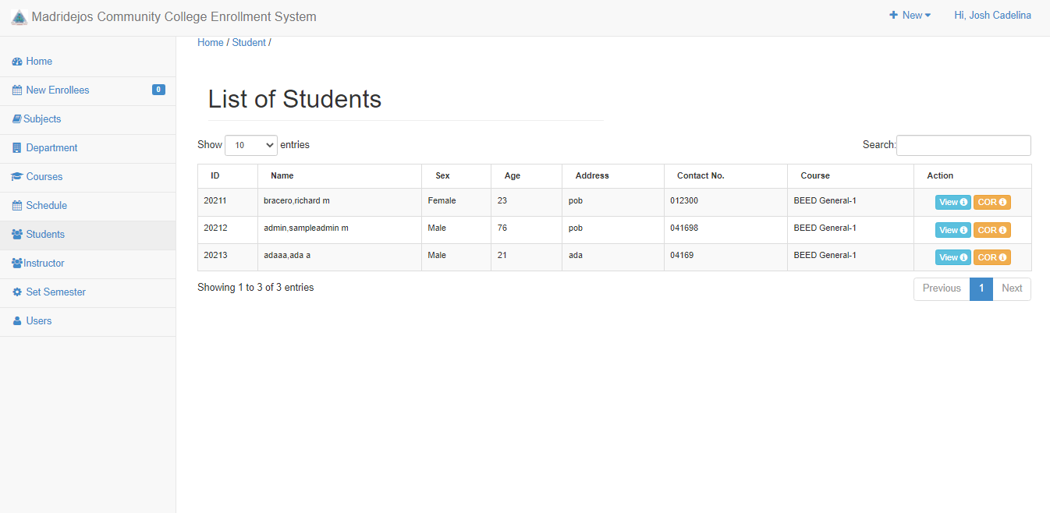

**Figure 10. In terms of managing, displaying, and updating records of students/enrolees**

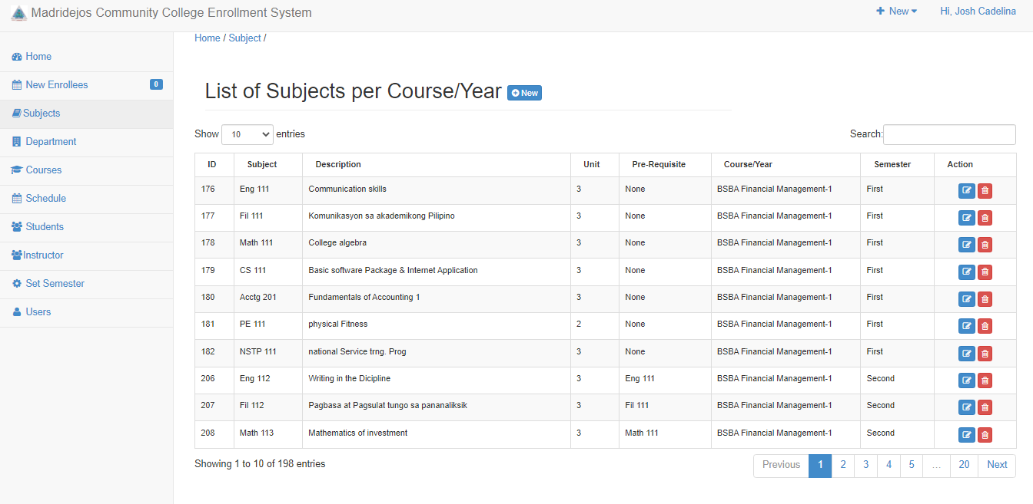Figure 10 above shows the part of the Madridejos Community College Enrollment System where the admin can manage student/enrollee records, display the data, and update records.

**Figure 11. In terms of Adding Subjects by Course & Year**

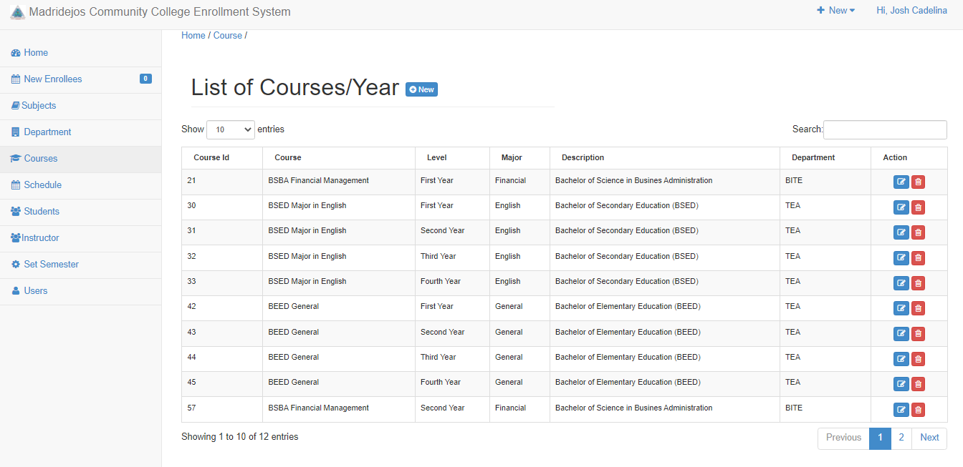 Figure 11 above shows the part of the Madridejos Community College Enrollment System where the admin can Add Subjects by Course & Year.

**Figure 12. In terms of Adding Courses**

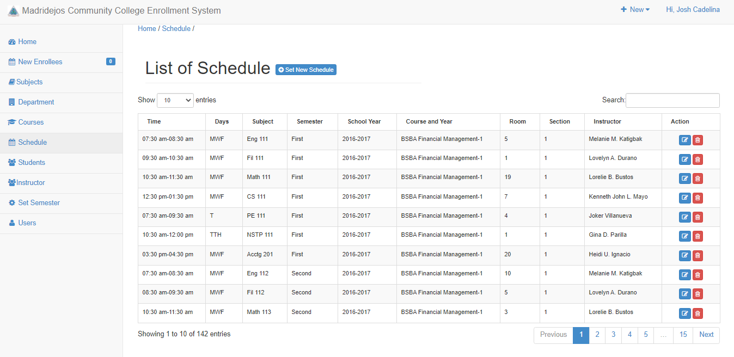 Figure 12 above shows the part of the Madridejos Community College Enrollment System where the admin can Add Courses by Year.

**Figure 13. In terms of Adding Class Schedules**

Figure 13 above shows the part of the Madridejos Community College Enrollment System where the admin can add class schedules.

|  |  |  |
| --- | --- | --- |
|  | **Mean** | **Verbal Interpretation** |
| It can display the data of total  number of enrolled students. | **4.33** | Very Satisfactory |
| It can display the data of number of enrolled male & female students. | **4.33** | Very Satisfactory |
| It can print the Certificate of  Registration. | **4.66** | Very Satisfactory |
| **Total** | **4.44** | **Very Satisfactory** |

**Table 2. In terms of displaying data of the total number of enrolled students, displaying data of the number of enrolled male and female students, and printing of certificate of registration**

Table 5 shows the expert’s feedback regarding the usefulness of the system based on displaying the total number of enrolled students, and number of enrolled male & female students. Printing of Certificate of Registration is also being rated as Very Satisfactory which garnered an average total of **4.44** which has a verbal interpretation of Very Satisfactory.



**Figure 14. Displaying data of the total number of enrolled students.**

 Figure 14 above shows the part of the Madridejos Community College Enrollment System where the admin can display the data of the total number of enrolled students.

**Figure 15. In terms of displaying data of the number of enrolled male and female students.**

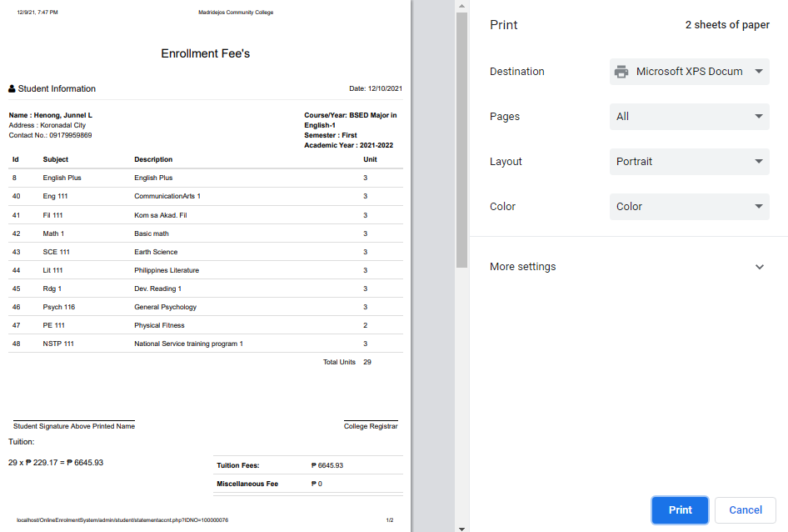 Figure 15 above shows the part of the Madridejos Community College Enrollment System where the admin can display the data of the number of enrolled male and female students.

**Figure 16. In terms of Printing Certificate of Registration.**

|  |  |  |
| --- | --- | --- |
| **Criteria** | **Mean** | **Verbal Interpretation** |
| Functional Suitability | **4** | Very Satisfactory |
| Performance Efficiency | **3.88** | Satisfactory |
| Compatability | **4.20** | Very Satisfactory |
| Reliability | **4.25** | Very Satisfactory |
| Security | **4.33** | Very Satisfactory |
| **Total** | **4.13** | **Very Satisfactory** |

Figure 16 above shows the part of the Madridejos Community College Enrollment System where the admin can print the Certificate of Registration.

**Table 3. In terms of the characteristics set in ISO 25010**

**Software Quality Model**

Table 6 shows the result of the IT Experts' feedback in determining the quality of the Madridejos Community College Enrollment System is based on the characteristics set in the ISO 25010 Software Qureality Model.

In terms of Functional Suitability, Performance Efficiency, and Compatibility, it was rated with a mean value of 4.02, which is interpreted as Very Satisfactory. Regarding Reliability, it was rated with a mean value of 4.25, which is interpreted as Very Satisfactory. As to Security, it was rated with a mean value of 4.33, which is interpreted as Very Satisfactory.

|  |  |  |
| --- | --- | --- |
| **Criteria** | **Mean** | **Verbal Interpretation** |
| Usefullness | **4.29** | Very Satisfactory |
| Ease of Use | **4.27** | Very Satisfactory |
| Ease of Learning | **4.33** | Very Satisfactory |
| Satisfaction | **4.48** | Very Satisfactory |
| **Total** | **4.34** | **Very Satisfactory** |

**Table 4. In terms of usefulness, satisfaction, and ease**

**of use and learning**

Table 4 shows the result of the user’s feedback in determining the usability of the Web-based Barangay Management System based on usefulness, satisfaction, and ease of use and learning.

In terms of Usefulness, it was rated with a mean value of **4.29** which is interpreted as **Very Satisfactory**. With regards to Satisfaction, it was rated with a mean value of **4.48**, which is interpreted as **Very Satisfactory**. As to Ease of Use, it was rated with a mean value of **4.27,** which is interpreted as **Very Satisfactory.** As Ease of Learning, it was rated with a mean value of **4.33**, which is interpreted as **Very Satisfactory**.

# **CHAPTER V**

**SUMMARY, CONCLUSION, AND RECOMMENDATIONS**

**Summary of Findings**

Based on a detailed presentation, discussions, interpretation, and analysis of research findings, the following summary is now presented:

1. In terms of managing, displaying, and updating records of students/enrollees, it was rated with a mean value of 4 which has a verbal interpretation of Very Satisfactory.
2. In terms of adding subjects by course and year, it was rated with a mean value of 4 which has a verbal interpretation of Very Satisfactory.
3. In terms of adding courses by year, it was rated with a mean value of 4.33 which has a verbal interpretation of Very Satisfactory.
4. In terms of determining the quality of the MCC Enrollment System with Machine Learning Integration based on the characteristics set in ISO 25010 Software Quality Model, it was rated with a mean value of 4.13, which is interpreted as Very Satisfactory.
5. In terms of determining the usability of the MCC Enrollment System based on usefulness, satisfaction, and ease of use and learning, it was rated with a mean value of 4.34, which is interpreted as Very Satisfactory.

**Conclusion**

The researcher was able to present the enrollment process, manage enrollees, displaying and updating of records or profiles. In addition, the researcher concludes that, based on the thorough evaluation of the IT experts that the Madridejos Community College Enrollment System is highly usable, secured, efficient, and provides a fast and easy way to manage enrollees' records, updating students/enrollees data, viewing the total number of enrolled students, printing certificate of registration, adding of courses, subjects, and class schedules.

In terms of enrolling, the Madridejos Community College Enrollment System is a fast and effective tool for the enrollment admin and staff. Also, by using this system, enrollment records are held in a single system, which can assist reduce paper enrollment forms, and misplaced forms.

The system can also print the certificate of registration in a manner of seconds. Many institutions are working hard to minimize the costs while retaining high-quality services, and digital innovation has provided the greatest option for many of them. Faster registration is possible with online enrollment methods. Enrollment systems, have several advantages since they let schools organize and manage their enrollment processes, saving time, and money. Therefore, by implementing the Madridejos Community College Enrollment System, online enrollment has made the registration process faster and more pleasant for employees/staff, freeing them from boring tasks by improving accuracy and reducing human errors.

**Recommendation**

Based on the findings and conclusion drawn, the following recommendations are put forward:

1. The Enrollment Admin of the Madridejos Community College may consider implementing this system to:
2. Manage student/enrollees records. This system can be effectively used as a personnel admin tool. This system can help the enrollment admin and staff to work faster in the processing of enrollee records. The reduction of paper works on the part of the enrollment admin and staff can save time & money.
3. Utilize the use of various report generating tools available in Madridejos Community College Enrollment System like printing of Certificate of Registration, enrollment fees, and schedules.
4. Use the graphical representation pertaining to the analyzed data of the students through diagrams containing total number of enrolled students and number of male & female students.
5. Further, it is also recommended that a similar study may be conducted to improve the Madridejos Community College Enrollment System in terms of printing the total number of students/enrollees by gender.

**REFERENCES**

**Internet Sources**

# BenefitMall (2021). Online Enrollment: simple, seamless, and secure - quote, consult with your client to select plans and enroll, online, it's all in one place. U.S. California. Retrieved on September 2, 2021 from <https://www.benefitmall.com/technology/online-enrollment/>

## Curacubby (2001-2021). How enrollments work and a step-by-step on how to enroll students. Retrieved on April 14, 2021 from <http://kb.curacubby.com/enrollments>

Enrollment System 1.0 (2021). Enrollment System is used in recording a students’ information. A complete enrollment system that can be used in recording a students’ information. Informer Technologies, Inc. Retrieved on Oct. 14, 2021 from <https://enrollment-system.software.informer.com/1.0/>

# [Ekmekci](https://onlinelibrary.wiley.com/action/doSearch?ContribAuthorRaw=Ekmekci%2C+Mehmet), Mehmet, & [Yenmez](https://onlinelibrary.wiley.com/action/doSearch?ContribAuthorRaw=Yenmez%2C+M+Bumin), M. Bumin (2019). Common enrollment in school choice. Retrieved on December 3, 2019 from <https://onlinelibrary.wiley.com/doi/full/10.3982/TE2631>

# Gallagher, Liam A. (2017). A Portfolio Approach to Assessing and Auto-Enrolment Pension Scheme for Ireland. Retrieved on December 15, 2017 from <https://www.esr.ie/article/view/825>

Kusuma, Purba Daru (2018). DISTANCE-SCORE COMBINED MODEL IN AUTOMATIC HIGH SCHOOL STUDENT ENROLLMENT SYSTEM. Retrieved on October 31, 2018 from <http://www.jatit.org/volumes/Vol96No20/5Vol96No20.pdf>

# LeadSquared (2021). Run your admissions and post admissions process on auto-pilot. Automate application process and student enrollment. Map end-to-end student journeys - inquiry, applications, counseling, enrollment, and beyond. US, India. Retrieved on Aug. 26, 2020 from <https://www.leadsquared.com/what-is-sales-dashboard/>

**Li-ge, Mao (2017). Central China Normal University;** Advantages and Disadvantages of Diversification Enrollment System Reform in Higher Vocational Education in China. **Central China Normal University. Retrieved from**

<https://en.cnki.com.cn/Article_en/CJFDTotal-JLKF201702011.htm>

## Miranda, Maria Grace P.; Barroso, Elisame P.; Antuerpia, John F.; Alcera, Jaina A.; Agustin, & Louie F (2019). ENROLLMENT SYSTEM WITH DESCRIPTIVE ANALYTICS. Retrieved on **March/April 2019 from**

<https://bit.ly/3FfKsAR>

# [Ruiz](https://www.sciencedirect.com/science/article/pii/S2214785321031333#!), Felix, [Chamilco, Pacheco,](https://www.sciencedirect.com/science/article/pii/S2214785321031333#!) & [Peñaranda](https://www.sciencedirect.com/science/article/pii/S2214785321031333#!) (2021, May 26). Materials and methods on digital enrollment system for educational institutions. Retrieved on May 26, 2021 from

# [https://www.sciencedirect.com/science/article/pii/S2214785321031333]( https://www.sciencedirect.com/science/article/pii/S2214785321031333)

[Rudolph](https://papers.ssrn.com/sol3/cf_dev/AbsByAuth.cfm?per_id=1271087), Heinz P. (2019). Pension Funds with Automatic Enrollment Schemes: Lessons for Emerging Economies. Retrieved on February 20, 2019 from <https://papers.ssrn.com/sol3/papers.cfm?abstract_id=3335093>

# Sutton, Halley (2019). Community college students face barriers to success, including registration. Retrieved on September 18, 2019 from <https://onlinelibrary.wiley.com/doi/abs/10.1002/nsr.30524>

### Singh, Kaur, Singh, Ravinder, [Gupta](http://ischolar.info/index.php/Oriental/search/authors/view?firstName=O.%20P.&middleName=&lastName=Gupta&affiliation=Punjab%20Agricultural%20University,%20Ludhiana,%20Punjab&country=IN), O. P. (2016). Development of Online Student Course Registration System. Retrieved on January 8, 2016 <http://ischolar.info/index.php/Oriental/article/view/140354>

SchoolCues (2020-2021). Online Student Enrollment Management System to Increase Enrollment in Small Schools. School Admissions System for Small Schools - The Intelligent School Admissions Management Solution. Retrieved on February 5, 2021 from <https://www.schoolcues.com/school-admission-and-enrollment-management-solution.html>

Softograph (2021). A web-based portal for Registration & Annual reporting system for the national authority in chemical weapons convention. House-42/A, Road-07, Sector-03, Uttara, Dhaka Bangladesh. Retrieved on January 8, 2021 from <http://www.softograph.com/portfolio/bnacwc-enrollment-system/>

TUIO (2021). The Best Enrollment Management and Student Registration System. A web-based online student registration system combines student recruiting, admissions, school waitlists, student information database, and student financials. Richmond St E Toronto, ON M5A 4S8. Retrieved on Aug 22, 2021 from <https://tuiopay.com/enrollment-management-system/>

### wits IT solutions (2017). Enrollment System: With just a click of a button, the printing of Transcript Records, Evaluation, CHED and TESDA Report, list of students, and schedule for teachers is never been easy. Room 205 3M Bldg, Dalahican Road Lucena City. Retrieved on Apr 1, 2021 from <https://mindweb.com.ph/mindwebs-online-enrollment-system-benefits/>

# Özen, Ercan (2020). Evaluation of willingness to have a pension plan in turkey and auto-enrollment system. Retrieved on September 2020 from <https://irek.ase.md/xmlui/handle/1234567890/956>

**APPENDICES**

# **APPENDIX A**

## EXPERT EVALUATION USING ISO/IEC 25010

## SOFTWARE QUALITY MODEL

**Name: _____________________ Company: _________________**

**Position: ________________ Specialization: ______________**

**Direction:** Listed below are the characteristics of a Software or Product as based on **ISO/IEC 25010 Software Quality Model**.

Each of the items is provided with five options. Please read each item carefully and **check (/)** the box that closely represents your choice.

Rating Scale:

[5] Very Good [4] Good [3] Average [2] Fair [1] Poor

How would you rate the developed system, **“MADRIDEJOS COMMUNITY COLLEGE ENROLLMENT SYSTEM”** in terms of the following software criteria:

|  |  |
| --- | --- |
| **Functional Suitability**  the degree to which a product or system provides functions that meet stated and implied needs when used under specified conditions |  |
| * **Functional completeness.** Degree to which the set of functions covers all the specified tasks and user objectives. | [1] [2] [3] [4] [5] |
| * **Functional correctness.** Degree to which a product or system provides the correct results with the needed degree of precision. | [1] [2] [3] [4] [5] |
| * **Functional appropriateness.** Degree to which the functions facilitate the accomplishment of specified tasks and objectives. | [1] [2] [3] [4] [5] |
| **Performance efficiency**  the performance relative to the amount of ddatas used under stated conditions |  |
| * **Time behaviour.** Degree to which the response and processing times and throughput rates of a product or system, when performing its functions, meet requirements. | [1] [2] [3] [4] [5] |
| * **Resource utilization.** Degree to which the amounts and types of resources used by a product or system, when performing its functions, meet requirements. | [1] [2] [3] [4] [5] |
| * **Capacity.** Degree to which the maximum limits of a product or system parameter meet requirements. | [1] [2] [3] [4] [5] |
| **Compatibility**  Degree to which a product, system or component can exchange information with other products, systems or components, and/or perform its required functions, while sharing the same hardware or software environment. |  |
| * **Co-existence.** Degree to which a product can perform its required functions efficiently while sharing a common environment and resources with other products, without detrimental impact on any other product. | [1] [2] [3] [4] [5] |
| * **Interoperability.** Degree to which two or more systems, products or components can exchange information and use the information that has been exchanged. | [1] [2] [3] [4] [5] |
| * **Appropriateness recognisability.** Degree to which users can recognize whether a product or system is appropriate for their needs. | [1] [2] [3] [4] [5] |
| * **Learnability.** degree to which a product or system can be used by specified users to achieve specified goals of learning to use the product or system with effectiveness, efficiency, freedom from risk and satisfaction in a specified context of use. | [1] [2] [3] [4] [5] |
| * **Operability.** Degree to which a product or system has attributes that make it easy to operate and control. | [1] [2] [3] [4] [5] |
| * **User error protection.** Degree to which a system protects users against making errors. | [1] [2] [3] [4] [5] |
| * **User interface aesthetics.** Degree to which a user interface enables pleasing and satisfying interaction for the user. | [1] [2] [3] [4] [5] |
| * **Accessibility.** Degree to which a product or system can be used by people with the widest range of characteristics and capabilities to achieve a specified goal in a specified context of use. | [1] [2] [3] [4] [5] |
| **Reliability**  Degree to which a system, product or component performs specified functions under specified conditions for a specified period of time |  |
| * **Maturity.** Degree to which a system, product or component meets needs for reliability under normal operation. | [1] [2] [3] [4] [5] |
| * **Availability**. Degree to which a system, product or component is operational and accessible when required for use. | [1] [2] [3] [4] [5] |
| * **Fault tolerance.** Degree to which a system, product or component operates as intended despite the presence of hardware or software faults. | [1] [2] [3] [4] [5] |
| * **Recoverability.** Degree to which, in the event of an interruption or a failure, a product or system can recover the data directly affected and re-establish the desired state of the system. | [1] [2] [3] [4] [5] |
| **Security**  Degree to which a product or system protects information and data so that persons or other products or systems have the degree of data access appropriate to their types and levels of authorization. |  |
| * **Confidentiality.** Degree to which a product or system ensures that data are accessible only to those authorized to have access. | [1] [2] [3] [4] [5] |
| * **Integrity.** Degree to which a system, product or component prevents unauthorized access to, or modification of, computer programs or data. | [1] [2] [3] [4] [5] |
| * **Non-repudiation.** Degree to which actions or events can be proven to have taken place, so that the events or actions cannot be repudiated later. | [1] [2] [3] [4] [5] |

# 

# **APPENDIX B**

## RESULTS OF EXPERT EVALUATION USING ISO/IEC 25010

## SOFTWARE QUALITY MODEL

|  |  |  |
| --- | --- | --- |
| **Criteria** | **Mean** | **Verbal Interpretation** |
| Functional Suitability | **4** | Very Satisfactory |
| Performance Efficiency | **3.88** | Satisfactory |
| Compatability | **4.20** | Very Satisfactory |
| Reliability | **4.25** | Very Satisfactory |
| Security | **4.33** | Very Satisfactory |
| **Total** | **4.13** | **Very Satisfactory** |

# 

# **APPENDIX C**

## EVALUATION INSTRUMENT

**USE Questionnaire: Usefulness, Satisfaction, and Ease of use**

Based on: Lund, A.M. (2001) Measuring Usability with the USE Questionnaire. STC Usability SIG Newsletter, 8:2.

**Name of System:** **MADRIDEJOS COMMUNITY COLLEGE ENROLLMENT SYSTEM**

Instruction: Please rate the system on how strongly you agree or disagree with each of the following statements by placing a check mark in the appropriate box.

**Legend:**

1 – Strongly Disagree 2 – Disagree

3 - Neither agree nor disagree 4 – Agree

5 – Strongly Agree

|  |  |  |  |  |  |
| --- | --- | --- | --- | --- | --- |
| **Usefulness** | **1** | **2** | **3** | **4** | **5** |
| It helps me be more effective. |  |  |  |  |  |
| It helps me be more productive. |  |  |  |  |  |
| It is useful. |  |  |  |  |  |
| It gives me more control over the activities in my life. |  |  |  |  |  |
| It makes the things I want to accomplish easier to get done. |  |  |  |  |  |
| It saves me time when I use it. |  |  |  |  |  |
| It meets my needs. |  |  |  |  |  |
| It does everything I would expect it to do. |  |  |  |  |  |

|  |  |  |  |  |  |
| --- | --- | --- | --- | --- | --- |
| **Ease of Use** | **1** | **2** | **3** | **4** | **5** |
| It is easy to use. |  |  |  |  |  |
| It is simple to use. |  |  |  |  |  |
| It is user friendly. |  |  |  |  |  |
| It requires the fewest steps possible to accomplish what I want to do with it. |  |  |  |  |  |
| It is flexible. |  |  |  |  |  |
| Using it is effortless. |  |  |  |  |  |
| I can use it without written instructions. |  |  |  |  |  |
| I don't notice any inconsistencies as I use it. |  |  |  |  |  |
| Both occasional and regular users would like it. |  |  |  |  |  |
| I can recover from mistakes quickly and easily. |  |  |  |  |  |
| I can use it successfully every time. |  |  |  |  |  |

|  |  |  |  |  |  |
| --- | --- | --- | --- | --- | --- |
| **Ease of Learning** | **1** | **2** | **3** | **4** | **5** |
| I learned to use it quickly. |  |  |  |  |  |
| I easily remember how to use it. |  |  |  |  |  |
| It is easy to learn to use it. |  |  |  |  |  |
| I quickly became skilful with it. |  |  |  |  |  |

|  |  |  |  |  |  |
| --- | --- | --- | --- | --- | --- |
| **Satisfaction** | **1** | **2** | **3** | **4** | **5** |
| I am satisfied with it. |  |  |  |  |  |
| I would recommend it to a friend. |  |  |  |  |  |
| It is fun to use. |  |  |  |  |  |
| It works the way I want it to work. |  |  |  |  |  |
| It is wonderful. |  |  |  |  |  |
| I feel I need to have it. |  |  |  |  |  |
| It is pleasant to use. |  |  |  |  |  |

List the most **negative** aspect(s):

_______________________________________________________________________________________________________________________________________________________________________________________________________________________________________________________________

List the most **positive** aspect(s):

_______________________________________________________________________________________________________________________________________________________________________________________________________________________________________________________________

# **APPENDIX D**

## EVALUATION INSTRUMENT

**Result of USE Questionnaire: Usefulness, Satisfaction, and Ease of use of MADRIDEJOS COMMUNITY COLLEGE ENROLLMENT SYSTEM**

Based on: Lund, A.M. (2001) Measuring Usability with the USE Questionnaire. STC Usability SIG Newsletter, 8:2.

|  |  |  |
| --- | --- | --- |
| **Criteria** | **Mean** | **Verbal Interpretation** |
| Usefullness | **4.29** | Very Satisfactory |
| Ease of Use | **4.27** | Very Satisfactory |
| Ease of Learning | **4.33** | Very Satisfactory |
| Satisfaction | **4.48** | Very Satisfactory |
| **Total** | **4.34** | **Very Satisfactory** |

**APPENDIX E**

**PLAGIARISM CHECK RESULT**

